Full Paper Title in Title Case
(Each Word of the Title Should be Capitalised)

Name Surname¹, Name Surname², Name Surname^{1*}

¹Department of Food Engineering, Faculty of Agriculture, Cukurova University, 01330 Adana, Turkey
² Department of Food Engineering, Faculty of Engineering, Adana Science and Technology University, 01110 Adana, Turkey
*Corresponding author: sselli@cu.edu.tr

ABSTRACT
This file provides a template for writing papers for the conference. The conference proceedings will be published in an electronic format only from the web page of conference. The full paper in MS Word file shall be written in compliance with these instructions. Later on it will be converted into Portable Document Format (PDF).
An abstract not exceeding 500 words should appear on the top of the first page, after the title of the paper in chapter titled "Abstract", after the names of the authors and the contact information of the corresponding author. It is possible to use the abstracts already published in the proceeding book.
Keywords: keyword1, keyword2, keyword3, keyword4, keyword5

INTRODUCTION
It is expected that authors will submit carefully written and proofread material. Spelling and grammatical errors, as well as language usage problems, are not acceptable. There is no strict limitation to the number of pages, but it is suggested that the paper length should not exceed 10 pages.
Papers should clearly describe the background of the subject, the authors work, including the methods used, and concluding discussion on the importance of the work. Papers are to be prepared in English (British or American) and SI units shall be used. Acronyms should be written out at their first appearance.

paper format
The uniform outlook will help the reader to follow the proceedings. This can be obtained most easily if authors use this template file to construct their papers. Please note the following details: this template is an A4 format with 20 mm margins left, right, top and bottom. Header and footer shall be positioned 16 mm from the edge.
All text paragraphs should be single spaced, with first line intended by 10 mm. Double spacing should only be used before and after headings and subheadings as shown in this example. Position and style of headings and subheadings should follow this example. No spaces should be placed between paragraphs. Please DO NOT change any of the above mentioned page, paragraph and font settings.

Header, Footer, Page Numbering
If this template is used when writing the full paper, headers and footers will be set automatically.

Fonts
Papers should use 12-point Times New Roman font. The styles available are bold, italic and underlined.
It is recommended that text in figures is not smaller than 10-point font size.

Tables and Figures
Figure captions and table headings should be sufficient to explain the figure or table without needing to refer to the text. Figures and tables not cited in the text should not be presented. Styles Heading Table and Caption Figure are available in this template for tables and figures.
The following is the example for Table 1.
Table 1: Title of Example Table
Header | X | Y
pH | 2,30 | 2,35
TSS (% Brix) | 9 | 9
Color Properties
L* | 51,76 | 44,59
a* | 22,18 | 37,90
b* | 17,35 | 15,40

Tables and figures should be placed close after their first reference in the text. All figures and tables should be numbered. Figure captions should be centred below the figures.

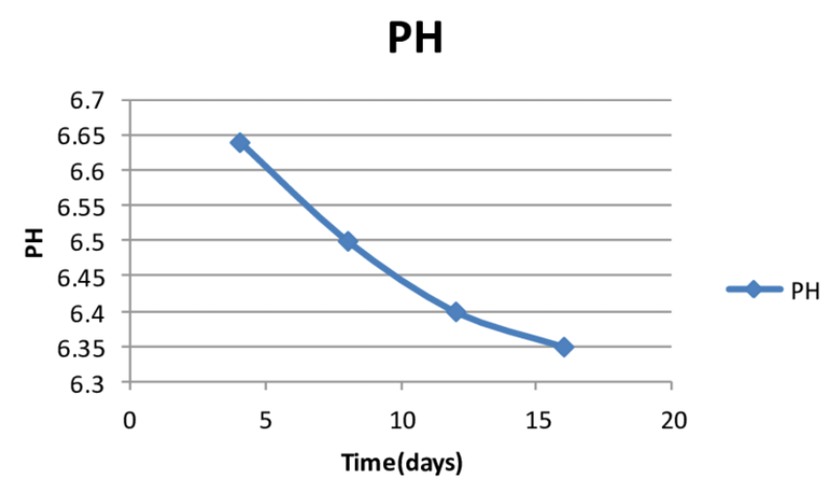
Figure 1: Title of Example Figure

Equations
Each equation should be presented on a separate line from the text with a blank space above and below. Equations should be clear and expressions used should be explained in the text. The equations should be numbered consecutively at the outer right margin, as shown in Eq. (1) and (2) below:
The number of different ways that a specified component can fail with (k-1) other components in a group of m similar components is:
$\left(\begin{matrix}m−1 \\ k−1\end{matrix}\right)=\frac{\left(m−1\right)!}{(k−1)!(m−k)!}$ (1)
Thus, the total failure probability, Q_{t}, of component in a common cause group of m components is:
$Q_{t}=\sum_{\text{k=}1}^{m}{\left(\begin{matrix}m−1 \\ k−1\end{matrix}\right)}Q_{k}^{(m)}$ (2)

References
References should be cited in the text in brackets, e.g., (Selli et al., 2018) or (Kelebek and Selli, 2017). The references should be listed in the same order as cited in the text. See also examples in the REFERENCES section of this template.

SUBMITTING THE Paper
The final versions of abstracts and papers should be submitted through the Conference website.

Conference Programme and proceedings
The Book of Abstracts and Proceedings with full papers will be published online from the conference web page.

conclusion
Conclusions should state briefly the most important propositions of the paper as well as the author’s views of the practical implications of the results.

REFERENCES
- Sonmezdag, A.S., Kelebek, H., Selli, S., (2018). Pistachio oil (Pistacia vera L. cv. Uzun): Characterization of key odorants in a representative aromatic extract by GC-MS-olfactometry and phenolic profile by LC-ESI-MS/MS. Food Chemistry, 240, 24–31. (for a paper in the journal)
- Selli, S., Guclu, G., Sevindik, O., Sonmezdag, A. S., Kelebek, H. (2017). GC-MS-Olfactometric characterization of key odorants in foods. 4th North and East European Congress on Food. (for a paper in the conference proceedings)
- J.R. Mahan, Radiation Heat Transfer, A Statistical Approach, John Wiley & Sons, New York, 2002. (for a book)

